

**LOVELY PROFESSIONAL UNIVERSITY**

**ACADEMIC TASK-2**

**CSE 307**

**Internet Working Essential**

**Submitted by:**

Name: Sethukumar Moorthy

Registration number: 12307650

Roll Number: RK23FSB26

Section: K23FS

**Submitted to: Bhupinder Kaur**

**GitHub-**[**https://github.com/SETHUKUMAR1709/Netwok-Planning**](https://github.com/SETHUKUMAR1709/Netwok-Planning)

**1. Introduction**

This report presents the physical and logical design of an office network infrastructure spread across 8 floors, with specific topologies and devices assigned to each floor. The network design emphasizes efficient communication, IP management, and the inclusion of essential network services.

**2. Network Topology and Device Setup**

Each floor contains 7 computers and uses a different topology as specified below:

| **Floor** | **Topology Used** | **Devices Used** |
| --- | --- | --- |
| 1–3 | Hybrid | Switch, Hub, PCs |
| 4–6 | Mesh | Switches, PCs |
| 7–8 | Bus | Hub, PCs |

**2.1 Devices Used**

* **Switch PT**: Used in Hybrid and Mesh topologies to connect multiple systems.
* **Hub PT**: Used in Hybrid and Bus topologies for shared communication.
* **Routers**: Used to connect networks on different floors and implement routing.
* **PCs & Laptops**: End devices across all floors.
* **Cables**: Cross cables and straight-through cables for appropriate connections.

**3. IP Addressing**

We used **FLSM** for IP allocation, starting with the base network 192.122.5.0/24. Each floor is assigned a /28 subnet (16 IPs), which is enough for 7 computers and networking devices. The new Subnet Mask is 255.255.255.240 (/28).

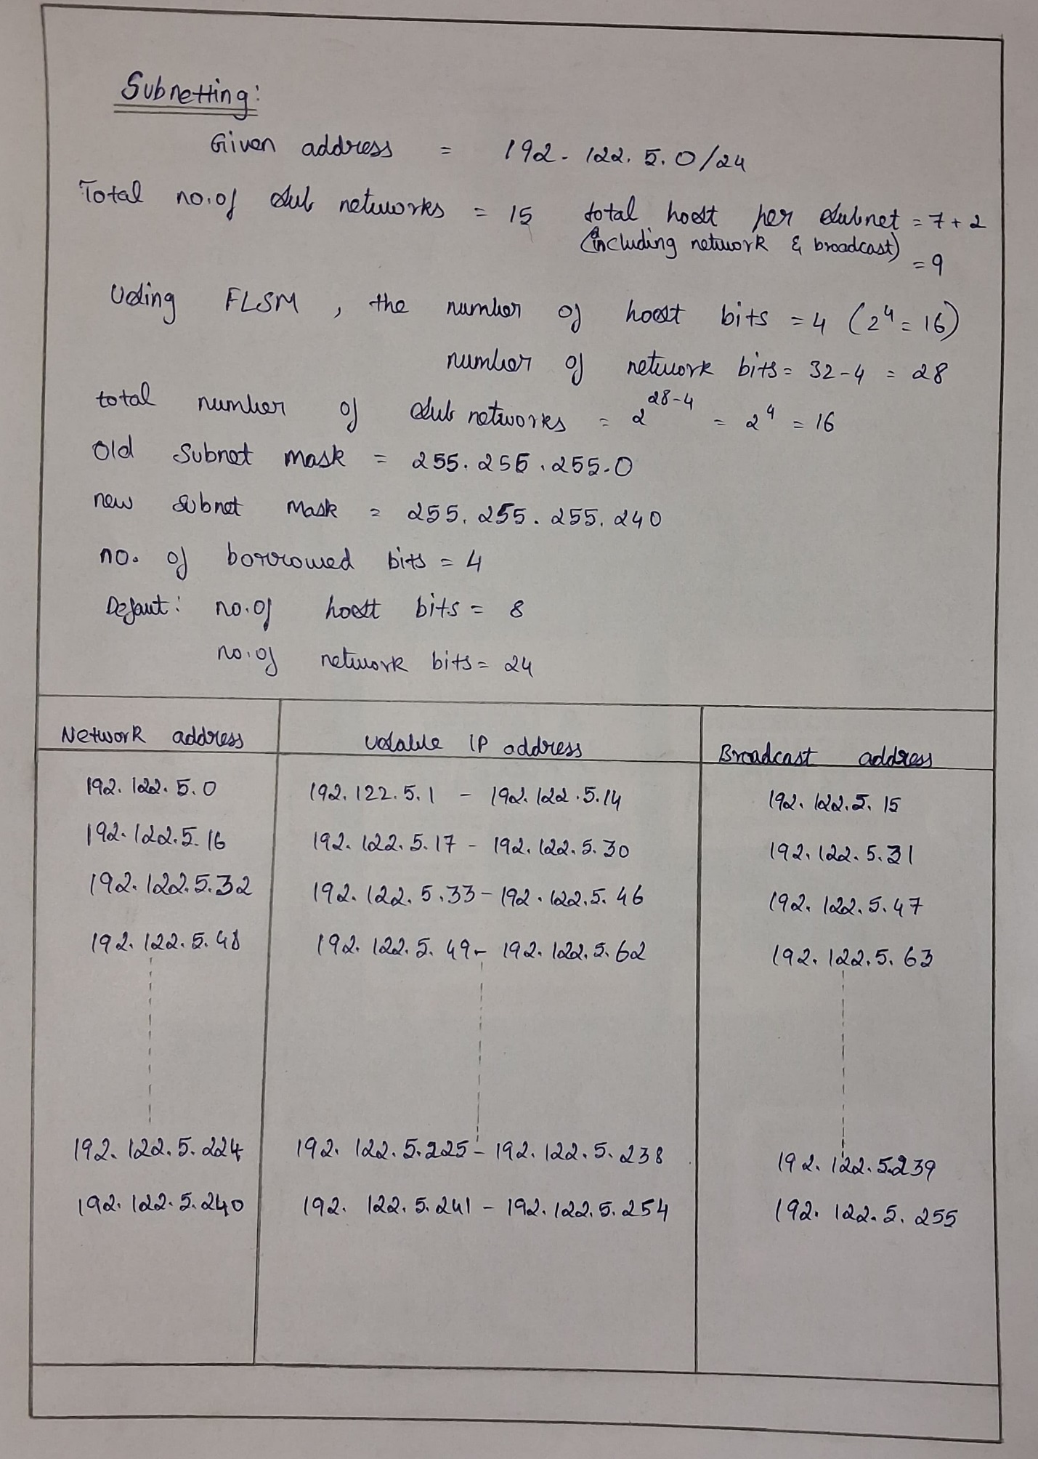

| **Subnet No.** | **Network Address** | **Usable IP Range** | **Broadcast Address** |  |
| --- | --- | --- | --- | --- |
| 1 | 192.122.5.0 | 192.122.5.1 – 192.122.5.14 | 192.122.5.15 |  |
| 2 | 192.122.5.16 | 192.122.5.17 – 192.122.5.30 | 192.122.5.31 |  |
| 3 | 192.122.5.32 | 192.122.5.33 – 192.122.5.46 | 192.122.5.47 |  |
| 4 | 192.122.5.48 | 192.122.5.49 – 192.122.5.62 | 192.122.5.63 |  |
| 5 | 192.122.5.64 | 192.122.5.65 – 192.122.5.78 | 192.122.5.79 |  |
| 6 | 192.122.5.80 | 192.122.5.81 – 192.122.5.94 | 192.122.5.95 |  |
| 7 | 192.122.5.96 | 192.122.5.97 – 192.122.5.110 | 192.122.5.111 |  |
| 8 | 192.122.5.112 | 192.122.5.113 – 192.122.5.126 | 192.122.5.127 |  |
| 9 | 192.122.5.128 | 192.122.5.129 – 192.122.5.142 | 192.122.5.143 |  |
| 10 | 192.122.5.144 | 192.122.5.145 – 192.122.5.158 | 192.122.5.159 |  |
| 11 | 192.122.5.160 | 192.122.5.161 – 192.122.5.174 | 192.122.5.175 |  |
| 12 | 192.122.5.176 | 192.122.5.177 – 192.122.5.190 | 192.122.5.191 |  |
| 13 | 192.122.5.192 | 192.122.5.193 – 192.122.5.206 | 192.122.5.207 |  |
| 14 | 192.122.5.208 | 192.122.5.209 – 192.122.5.222 | 192.122.5.223 |  |
| 15 | 192.122.5.224 | 192.122.5.225 – 192.122.5.238 | 192.122.5.239 |  |
| 16 | 192.122.5.240 | 192.122.5.241 – 192.122.5.254 | 192.122.5.255 |  |

**4. Routing Setup**

The routing between the floors is implemented using **Dynamic Routing (RIP)**.

**Routing Configuration Steps**:

* Routers are configured using both CLI and Packet Tracer UI.
* RIP allows automatic route updates between floors.
* CLI Commands:

arduino

CopyEdit

Router> enable

Router# config terminal

Router(config)# router rip

Router(config-router)# version 2

Router(config-router)# network 192.122.5.0

**5. Inter-Floor Communication**

* Floors 1–6 are connected in a series using routers.
* Floors 6–8 are connected via an additional router.
* Communication was tested using the command:

php-template

CopyEdit

ping <target IP>

This confirmed successful inter-floor data transmission.

**6. Server Configuration**

Each floor has been assigned a specific network service hosted on a server. These servers are configured with static IPs from their floor subnet.

| **Floor** | **Server Type** | **Purpose** |
| --- | --- | --- |
| 4 | DHCP Server | Automatically assigns IP addresses to client devices (like PCs) on the network without manual configuration. |
| 5 | DNS Server | Translates domain names (like [www.example.com](http://www.example.com)) into IP addresses. This is essential for web browsing and email routing. |
| 6 | HTTP Server | Hosts web pages and delivers HTML content over the web using HTTP/HTTPS. Can simulate a company website or internal portal. |
| 7 | Mail Server | Handles sending and receiving of emails within the network. Works using SMTP for sending and POP3/IMAP for receiving. |

**7. Full Network Topology**

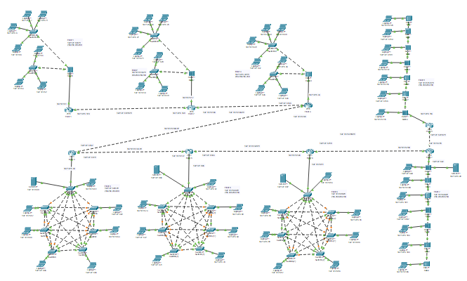

**8. Floor-wise Layouts and Configurations**

* **Floors 1–3**: Hybrid Topology

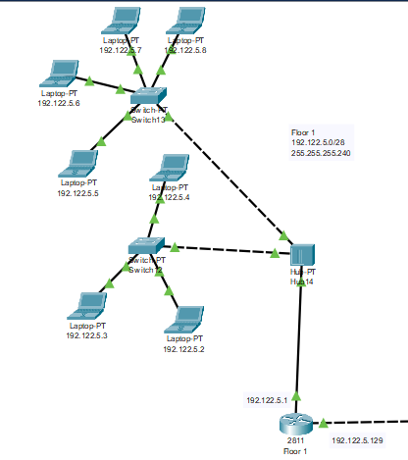

* **Floors 4–6**: Mesh Topology

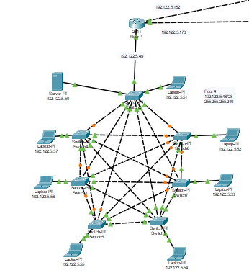

* **Floors 7–8**: Bus Topology  
  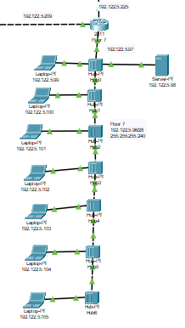
* **Router & PC Configuration**:

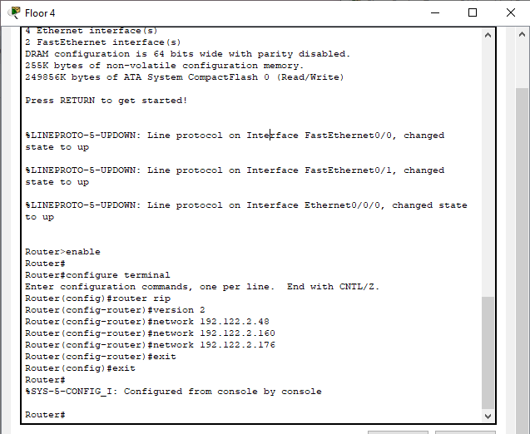

* **Working:**

